**DAYLESFORD LAWN TENNIS CLUB**

**JUNIOR TENNIS INFORMATION SHEET**

**SATURDAY MORNINGS 9.15am - 12.00pm**

**WELCOME** to a new season of Junior Tennis at Daylesford Lawn Tennis Club.

Junior tennis is a great way to learn tennis skills, meet new friends, play in a team, get active and **have fun**.

Junior tennis is for 5-18-year-old players. The players are grouped according to their ability.



**WHO WILL I PLAY TENNIS WITH?**

Tennis groups comprise of a number of “sections” ranging from beginners through to experienced players.

Junior tennis is a “doubles” competition. This means that you will always play with another rotating player on your side.

SECTION GROUPS

The number of sections will depend on the number of players registered on the day.

Usually the players will be grouped into section of a maximum of 8 – 10 players.

* Players are grouped according to their ability which is determined by the Junior Coordinator each week
* While some players want to play with their friends this may not always be possible if their ability is not the same.
* Players in each section play “doubles” and your playing partner will rotate through each player in the section.
* Players aged 14 – 18 who are competent players are also able to play senior tennis in the afternoon.

**HOW MUCH DOES IT COST?**

All junior tennis players must become members of the tennis club so that they are covered by our insurance. If players do not become members then they are also ineligible to play in competitions and the junior club championships.

By taking out an annual membership juniors are providing great support to keep our tennis club operating. Junior membership must be paid in full by the end of November. If any families have difficulties in the cost of the membership, then please contact us to discuss further.

**JUNIOR MEMBERSHIP = $ 85.00**

The easiest way to join is online where you can pay by credit card or bank transfer. Go to our webpage: <https://www.daylesfordtennis.com/membership>

**BALL MONEY = $2.00 each week**

Ball money enables the club to provide good quality balls for the juniors and also to cover the cost of trophies and prizes for the competitions.

Ball money must be paid at the clubhouse each week when registering to play.

**WHAT SHOULD I BRING TO TENNIS?**

* **A HAT**
* **SUNSCREEN ALREADY APPLIED**
* **A WATER BOTTLE**
* **TENNIS RACQUET**
* **COMFORTABLE SPORTS CLOTHES**
* **TENNIS SHOES/RUNNERS**
* **$2 BALL MONEY**

**PARENT INVOLVEMENT EACH WEEK**

Junior tennis players enjoy having parents/ carers watch and support them in playing tennis.

The club is not able to run a junior tennis competition unless parents/ carers are actively involved in assisting each Saturday morning.

Some parents/ carers have never played tennis before and do not know the rules or the scoring system – that is OK you can still help. A roster will be established for the season and will include each family in it. If you can’t make your rostered time then you must arrange a swap with another family.

What will I have to do?

* Be responsible for a section and make sure that play is fair and behaviour is sporting.
* Encourage and help players to learn the rules.
* Make sure that the players are moving quickly and not wasting time.
* Help the players to return the balls between points under the net back to the server.
* Help fill out the section scoring sheet.

All parents must complete a [contact information sheet](https://docs.wixstatic.com/ugd/c8c968_fcd4b9c5d4e44ef5a5359ceba4499ec3.pdf) at the time of enrolling their child in the program. Email and mobile phone numbers are necessary to enable quick communication where required.

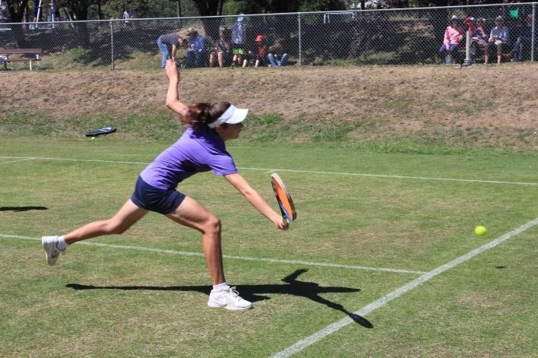

**WHAT ABOUT THE WEATHER?**

As we play on grass courts, wet weather can mean that the courts are slippery and dangerous to play on. If it is raining at 8.30am it is unlikely that any tennis will be played.

As tennis is a summer sport, excessive heat will also mean that play may be suspended. If the temperature is above 35C or a Code Red fire day then no play will occur.

Parents should ***like*** [***the Daylesford Lawn Tennis Facebook page***](https://www.facebook.com/DaylesfordLawnTennisClub/) to receive updates or follow the link from our website to the Facebook page to find out if play is on.

**BEING GOOD SPORTS**

The Daylesford Tennis Club requires good sporting behaviour and it is important that junior tennis players act and behave in a sporting manner.

**DO**

* Arrive on time so that others are not kept waiting;
* Come dressed to play tennis in comfortable sports clothes and tennis shoes;
* Try and improve your game by watching and learning from others;
* Acknowledge a good shot from your opponent or your partner;
* Encourage your partner if they hit a bad shot;
* Always respect the decision of the umpire and the player calling the lines;
* Always return the ball to the server under the net and directly to them.

**DON’T**

* Throw your racquet;
* Swear or make rude comments – even if having a joke;
* Criticise your partner or opposition players;
* Call the ball out if it’s on the line;
* Talk during and in between points;
* Hit the ball back to the server hard and waste time;
* Question the calls of the umpire or parent helper
* Celebrate points like you have just won the Australian Open!

**Points in a game will be awarded against players who do not show good sporting behaviour.**

**DATES FOR 2024 - 25**

The start date for Junior tennis is 26 October 2024. This date is subject to weather and court condition. Any changes will be posted on the club’s facebook page.

**THERE WILL BE NO TENNIS OVER THE SCHOOL HOLIDAY PERIOD AND MARCH LONG WEEKEND**

All players are welcome to play tennis informally over this break. Tennis finishes in mid – late March 2025 with a final presentation day for all players and families.

This date will be advised.

**CONTACT FOR FURTHER INFORMATION:**

**Steph Barron, Junior Tennis Coordinator** [stephiebarron@yahoo.com](mailto:stephiebarron@yahoo.com) 0437 115 999

**website** [**www.daylesfordtennis.com**](http://www.daylesfordtennis.com/)